**LAB - 3**

**BASIC EXPERIMENTS IN IMAGE PROCESSING**

**PRIYANSHU SHARMA**

**15BCE1282**

**MATLAB CODE -**

clc

clear all

a=imread('C:\Users\PRIYANSHU SHARMA\Desktop\PRIYANSHU\6 STUDY\MATLAB\2.jpg');

figure, imshow(a)

title('INPUT IMAGE');

**OUTPUT**

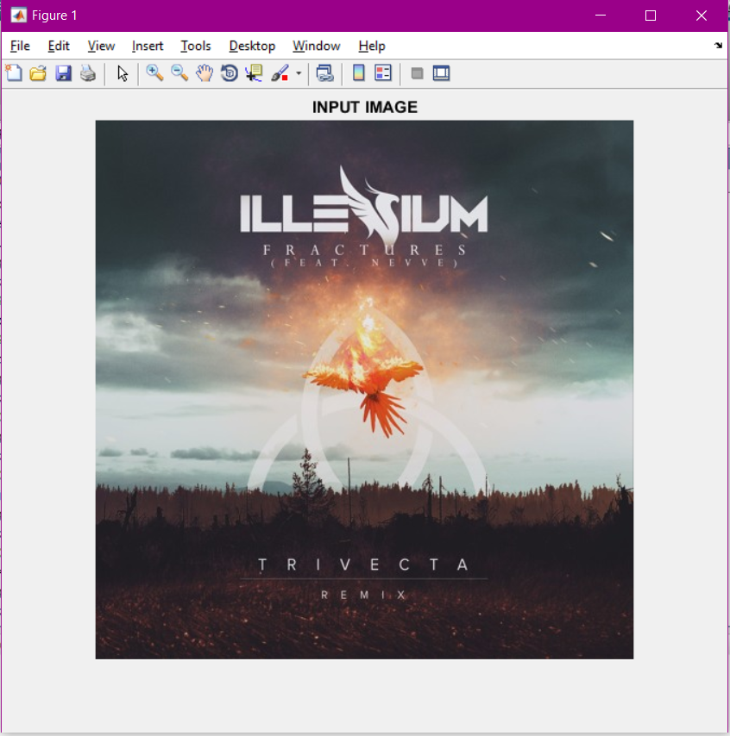

%%SIZE OF INPUT IMAGE

size(a)

**OUTPUT**

ans =

501 499 3

%%GREYSCALE IMAGE OF INPUT IMAGE

g=rgb2gray(a);

figure, imshow(g)

title('GREYSCALE IMAGE');

**OUTPUT**

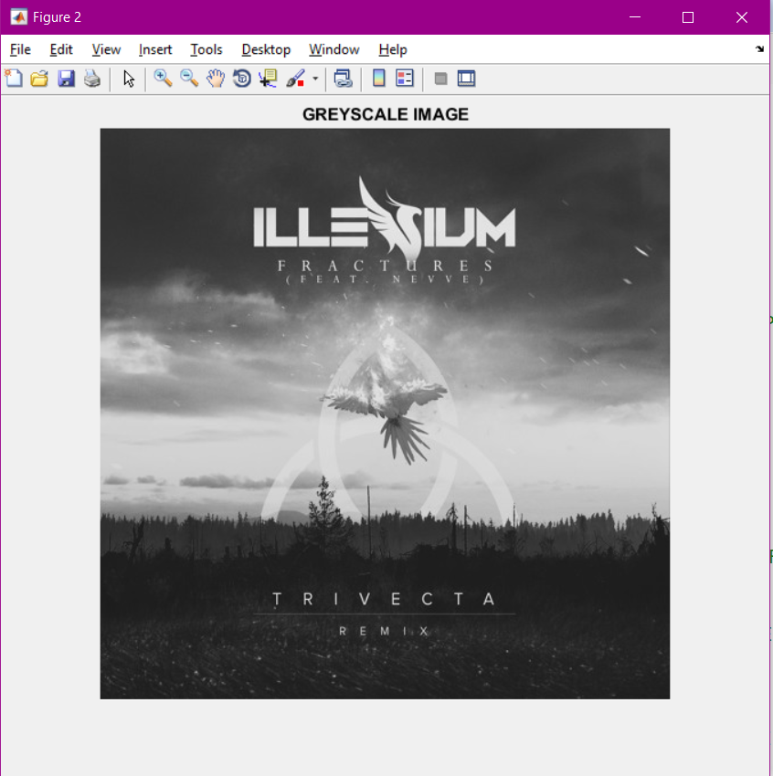

%%CREATING HISTOGRAM OF THE INPUT IMAGE

figure, imhist(g)

title('HISTOGRAM');

**OUTPUT**

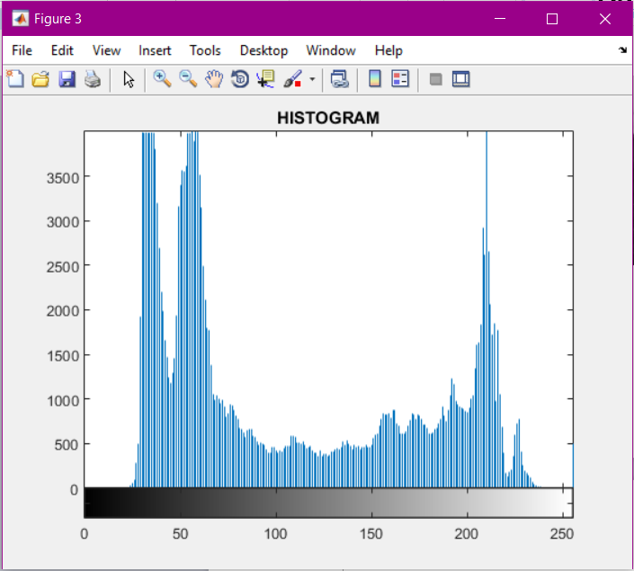

%%CREATING ADJUST IMAGE

adj=imadjust(g,[0.3,0.7],[]);

figure, imshow(adj)

title('ADJUST IMAGE');

**OUTPUT**

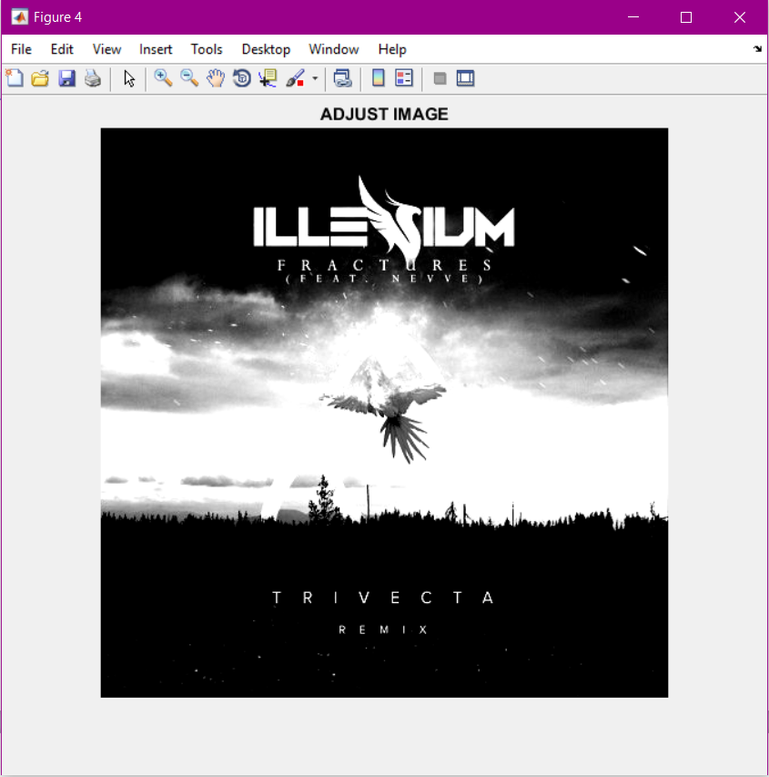

%%CREATING BINARY IMAGE OF INPUT IMAGE

bi=im2bw(adj);

figure, imshow(bi)

title('BINARY IMAGE');

**OUTPUT**

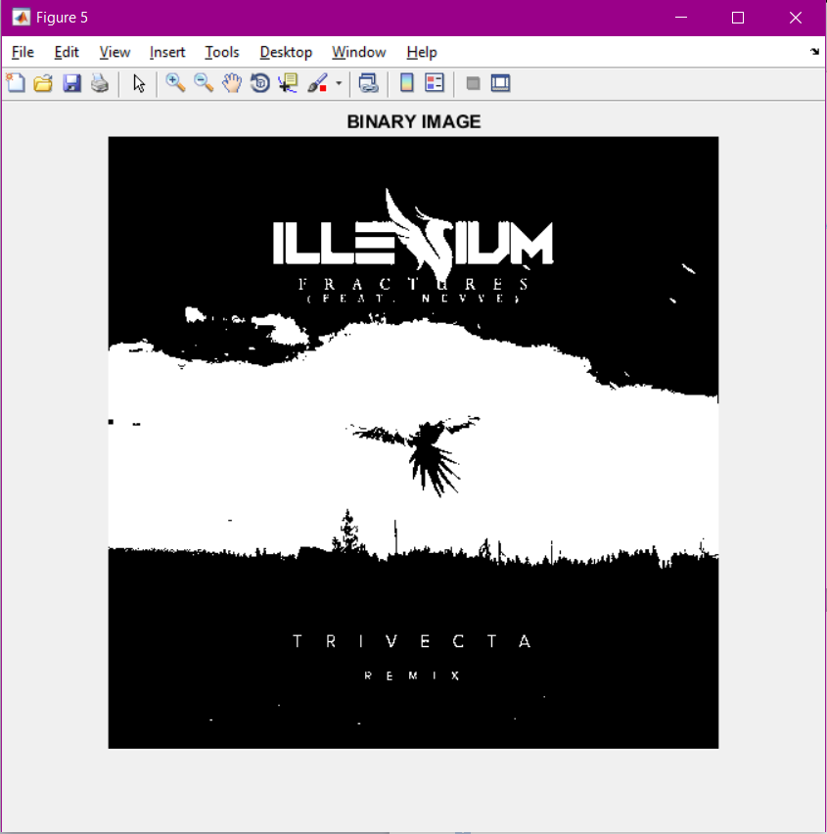

%%GETTING INFO OF THE INPUT IMAGE

info=imfinfo('C:\Users\PRIYANSHU SHARMA\Desktop\PRIYANSHU\6 STUDY\MATLAB\2.jpg');

Info

**OUTPUT**

info =

Filename: 'C:\Users\PRIYANSHU SHARMA\Desktop\PRIYANSHU\6 STUDY\MATLAB\2.jpg'

FileModDate: '18-Jul-2017 09:10:34'

FileSize: 372664

Format: 'png'

FormatVersion: []

Width: 499

Height: 501

BitDepth: 24

ColorType: 'truecolor'

FormatSignature: [137 80 78 71 13 10 26 10]

Colormap: []

Histogram: []

InterlaceType: 'none'

Transparency: 'alpha'

SimpleTransparencyData: []

BackgroundColor: []

RenderingIntent: 'perceptual'

Chromaticities: [0.3127 0.3290 0.6400 0.3300 0.3000 0.6000 0.1500 0.0600]

Gamma: 0.4545

XResolution: 3779

YResolution: 3779

ResolutionUnit: 'meter'

XOffset: []

YOffset: []

OffsetUnit: []

SignificantBits: []

ImageModTime: []

Title: []

Author: []

Description: []

Copyright: []

CreationTime: []

Software: []

Disclaimer: []

Warning: []

Source: []

Comment: []

OtherText: []

%%GETTING COLORMAP OF THE INPUT IMAGE

[IND,map] = rgb2ind(a,32);

figure('NAME','Indexed image with 32 Colors');

imshow(IND);

colormap(map)

title('COLORMAP');

**OUTPUT**

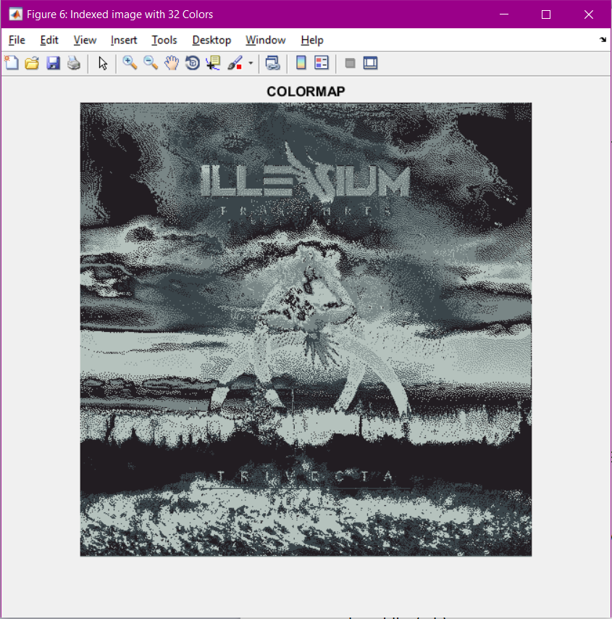

%%APPLYING NOISE TO IMAGE

n=imnoise(g,'gaussian',0,0.025);

figure, imshow(n)

title('NOISE IMAGE');

**OUTPUT**

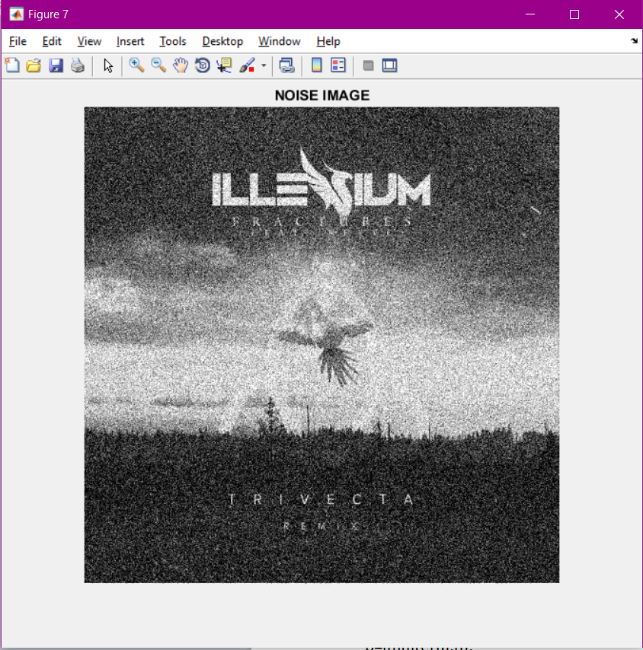

%%APPLYING WIENER FILTER TO IMAGE

w=wiener2(n,[6,6]);

figure, imshow(w)

title('WIENER FILTERED IMAGE');

**OUTPUT**

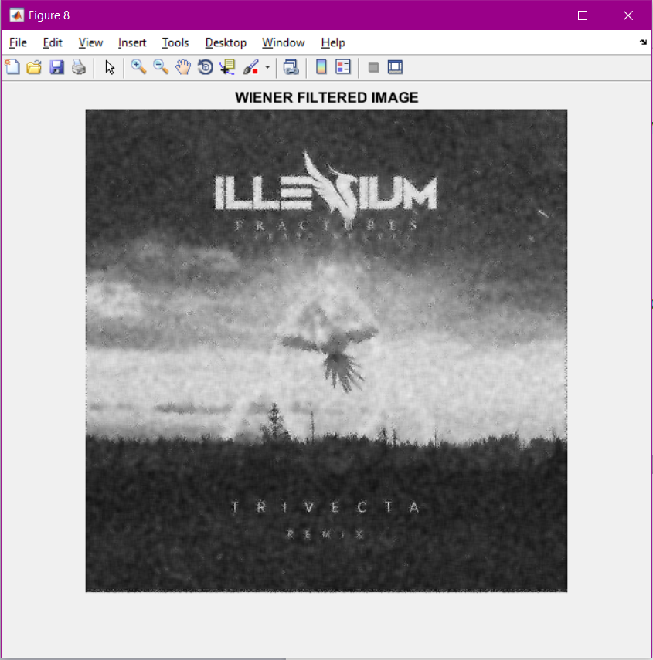

%%APPLYING LAPLACIAN FILTER TO IMAGE

%%creating laplacian filter

h=fspecial('laplacian');

%%aplying it

b=imfilter(a,h);

figure, imshow(b)

title('LAPLACIAN FILTERED IMAGE');

**OUTPUT**

